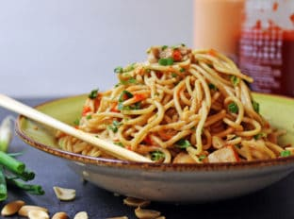
Asian Peanut Noodles
Prep Time 10 minutes Cook Time 5 minutes
4 Servings

Ingredients
1 lb. thin spaghetti
6 cups chicken stock
or 6 cups water and 2 heaping tablespoons of Chicken Better Than Bouillon
3 Tbsp lite soy sauce
3 Tbsp peanut butter
Sriracha sauce to taste, mom and Heather liked ½ Tbsp for a pound of pasta
Crushed peanuts (optional)
Sliced green onions (optional)
4 pieces cooked chicken, cut in 1inch cubes or shredded (optional)

Directions
- Cook the noodles on high with stock for 5-7 minutes
- Drain off 90% of the stock
Food Prep – Use all stock
- Add 3 tbs soy sauce, 3 tbs peanut butter, 1 tbsp sriracha and all chicken, if used.
- Mix well.
- Add peanuts and green onions if you want to get fancy!

